Chapter 6 Test Study Guide
How Cells Harvest Chemical Energy
In eukaryotes, cellular respiration harvests energy from food and yields large amounts of ATP, which cells use to function. The original source of energy is the sun.

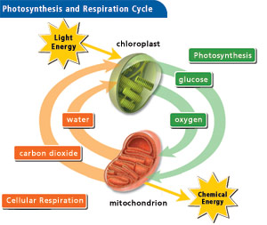
6.1 – The relationship between cellular respiration and photosynthesis
- How are the processes related?
  - Depend on one another
  - Plants use both of these processes
  - Animals eat plants, then perform CR
- Both plant and animal cells undergo CR
  - Both have mitochondria
- Only plant cells undergo photosynthesis
  - Have chloroplasts

6.2 – Breathing supplies oxygen for use in cellular respiration and removes carbon dioxide
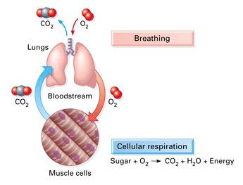
Breathing (respiration)
- Inhale
  - oxygen goes from lungs to blood
  - then diffuses into body’s cells
- Exhale
  - CO₂ diffuses out of body’s cells
  - then goes from blood to lungs
- This is diffusion! (passive transport)

6.3 – Cellular respiration banks energy in ATP molecules
- CR is an exergonic process that transfers energy from the bonds in glucose to form ATP
  - Energy is released gradually (not like burning a marshmallow!)
- Other foods (organic molecules) can also be used as a source of energy
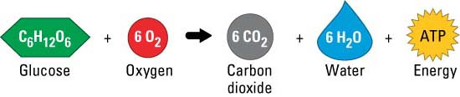
6.4 – CONNECTION: The human body uses energy from ATP for all its activities
- Average adult human needs about 2,200 kcal of energy per day
  - About 75% of these calories are used to maintain a healthy body
  - Brain utilizes 120 g or ¼ lb. of total glucose per day and approx. 15% of total oxygen
- Kilocalorie (kcal)
  - Quantity of heat required to raise the temperature of 1 kilogram (kg) of water by 1°C
  - Same as a food “calorie”

6.5 – Cells tap energy from electrons “falling” from organic fuels to oxygen
- The energy necessary for life is contained in the arrangement of electrons in chemical bonds in organic molecules
- How do cells extract this energy?
  - When carbon-hydrogen bonds of glucose are broken, electrons are transferred to O₂
    - O₂ has a strong tendency to attract electrons (“electron acceptor”)
    - Electrons use potential energy when it “falls” to O₂
  - Movement of electrons from one molecule to another is an oxidation-reduction reaction (a.k.a. “redox reaction”)
    - Oxidation: loss of electrons from one substance
      - A molecule is oxidized when it loses one or more electrons
    - Reduction: addition of electrons to another substance
      - A molecule is reduced when it gains one or more electrons
    - Oxidation and reduction always happen together
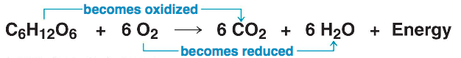

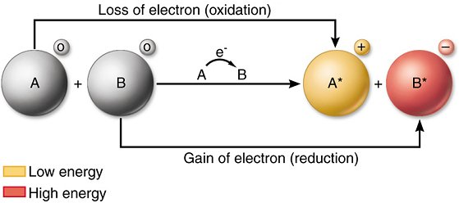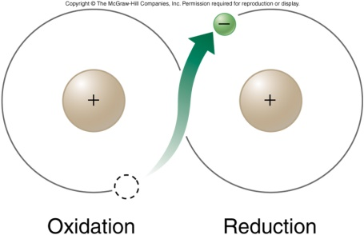
- Enzymes are necessary to oxidize glucose and other foods
  - NAD⁺ (nicotinamide adenine dinucleotide)
    - Important enzyme in oxidizing glucose
    - Accepts electrons
    - Becomes reduced to NADH (hydrogen added)
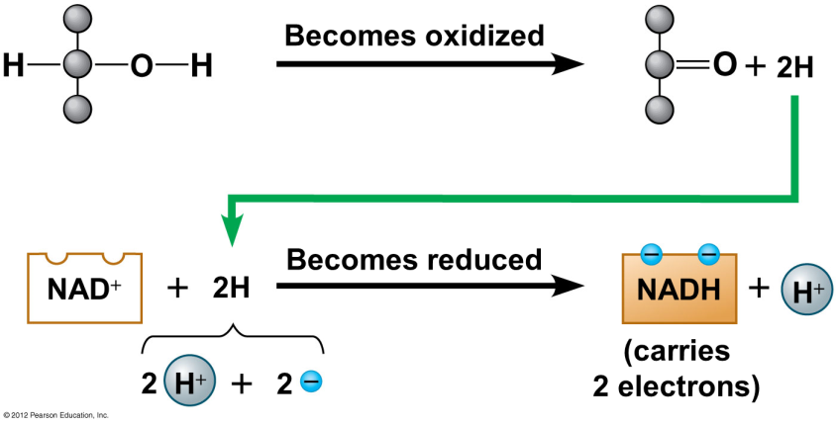
- There are other electron “carrier” molecules that function like NAD⁺
  - They form a staircase where electrons pass from one to the next down the staircase
  - Electron carriers collectively called “the electron transport chain”
  - As electrons are transported down the chain, ATP is generated
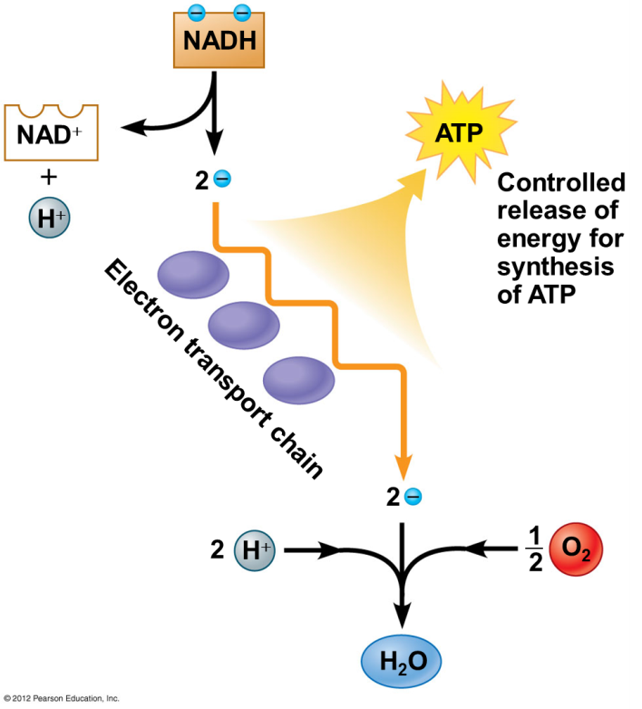

6.6 – Overview: Cellular respiration occurs in three main stages
- Glycolysis
  - Anaerobic (no oxygen needed)
  - Takes place in the cytoplasm
  - Begins cellular respiration
  - Breaks down glucose into two molecules of a three-carbon compound called pyruvate
- Citric acid cycle
  - Aerobic (oxygen needed)
  - Takes place in the mitochondrial matrix
  - Oxidizes pyruvate to a two-carbon compound
  - Supplies the third stage with electrons
- Oxidative phosphorylation
  - Aerobic (oxygen needed)
  - Takes place in/on the inner mitochondrial membrane
  - Involves electrons carried by NADH and FADH₂
  - Shuttles these electrons to the electron transport chain embedded in the inner mitochondrial membrane
  - Involves chemiosmosis
  - Generates ATP through oxidative phosphorylation associated with chemiosmosis
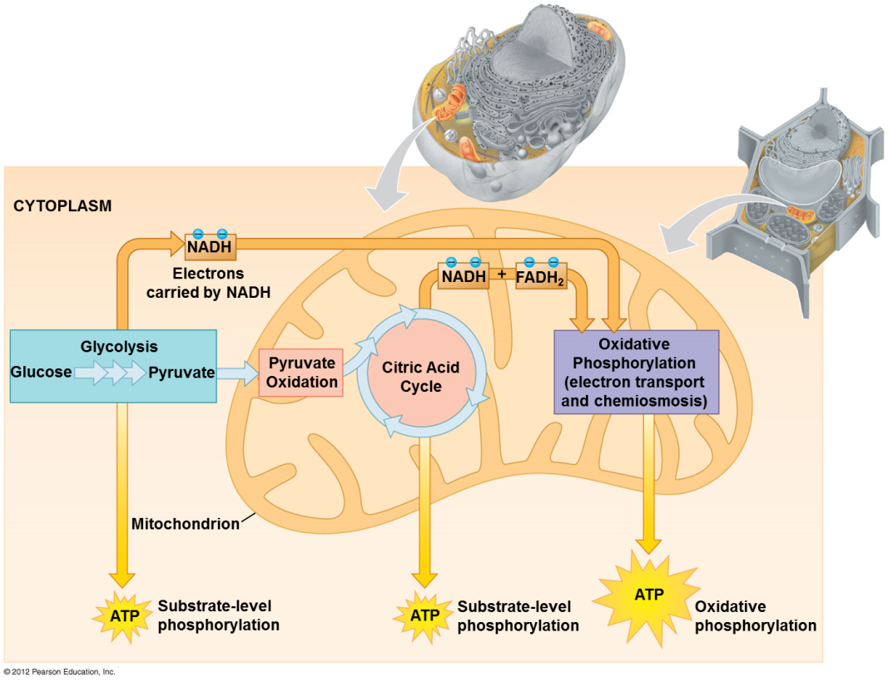

  - – Glycolysis harvests chemical energy by oxidizing glucose to pyruvate
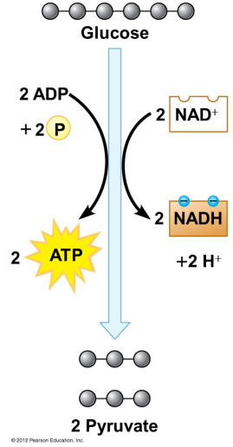
- Glycolysis = “splitting of sugar” (glyco = “sugar”, lysis = “split”)
  - Single molecule of glucose is enzymatically cut in half through a series of steps
    - Arrow in center represents 9 chemical steps
    - Gray circles represent carbon atoms
  - 2 molecules of pyruvate (pyruvic acid) are produced
  - 2 molecules of NAD⁺ are reduced to 2 molecules of NADH
  - Net of 2 molecules of ATP produced (4 gained - 2 used = 2 net)
  - Takes place in the cytoplasm
  - Oxygen is not required (anaerobic)
    - Will happen with or without oxygen; does not matter
- ATP is formed in glycolysis by substrate-level phosphorylation
  - Enzyme transfers phosphate group from substrate molecule to ADP
  - ATP is formed
- Intermediates: compounds formed between initial reactant (glucose) & final product (pyruvate)
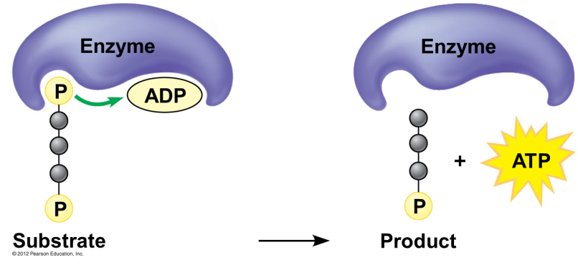
The steps of glycolysis can be grouped into two main phases.
- Steps 1-4: the energy investment phase
  - Energy is consumed as 2 ATP molecules are used to energize a glucose molecule
  - Which is then split into 2 small sugars that are now primed to release energy
- Steps 5-9: the energy payoff
  - 2 NADH molecules are produced for each initial glucose molecule
  - 4 ATP molecules are generated
Reactants used in glycolysis:
- Glucose
- 2 ATP (investment steps)
- 4 ADP
- 2 NAD
Products produced in glycolysis:
- 4 ATP’s (net gain of 2 due to the 2 used in investment)
- These ATP can be used by the cell
- 2 NADH (will go to the ETC)
- 2 pyruvate (in the presence of O2 will be “groomed” then go to the citric acid cycle)

  - – Pyruvate is oxidized prior to the citric acid cycle
- This process will not proceed without oxygen (aerobic)
- Pyruvate formed in glycolysis is transported from cytoplasm into a mitochondrion
  - Citric acid cycle and oxidative phosphorylation will occur
- 2 molecules of pyruvate are produced for each molecule of glucose that enters glycolysis
- Pyruvate does not enter citric acid cycle, but undergoes chemical grooming
  - Carboxyl group is removed and given off as CO₂
  - Remaining 2-carbon compound is oxidized while a molecule of NAD⁺ is reduced to NADH
  - Coenzyme A joins with 2-carbon group to form acetyl coenzyme A (acetyl CoA)
  - Acetyl CoA enters citric acid cycle

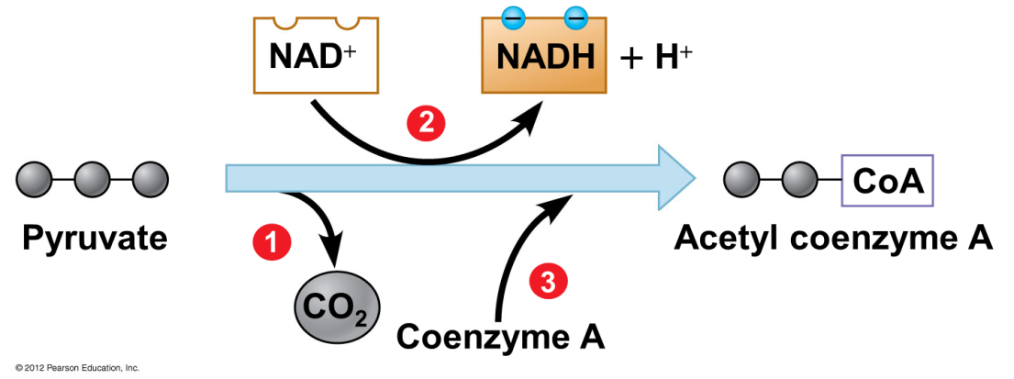

6.9 – The citric acid cycle
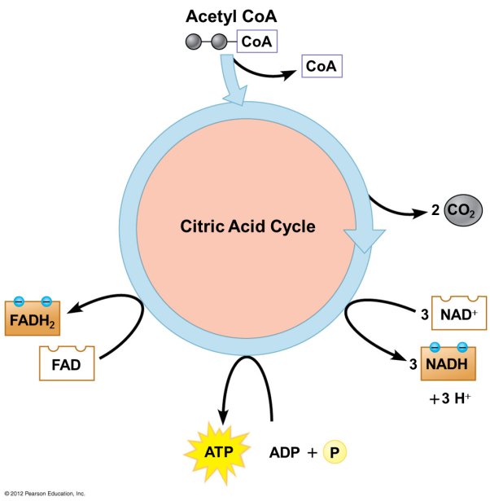
The citric acid cycle
- “Krebs cycle” (German-British researcher Hans Krebs – worked out much of pathway in 1930s)
- Completes the oxidation of organic molecules
- Generates many NADH and FADH₂ molecules
- During the citric acid cycle
  - 2-carbon group of acetyl CoA is added to a 4-carbon compound, forming citrate
  - Citrate is degraded back to 4-carbon compound
  - 2 CO₂ are released
  - 1 ATP, 3 NADH, and 1 FADH₂ are produced
- Remember: citric acid cycle processes two molecules of acetyl CoA for each initial glucose
- Overall yield per glucose molecule after two turns of the citric acid cycle:
  - 2 ATP (useable by the cell)
  - 6 NADH
  - 2 FADH₂
    - To the electron transport chain
- Each time a carbon (gray circles) is lost from a carbon compound, a CO₂ is produced
- NAD⁺ → NADH and FAD → FADH₂ as molecules in the citric acid cycle rearrange and energy is released as high energy electrons
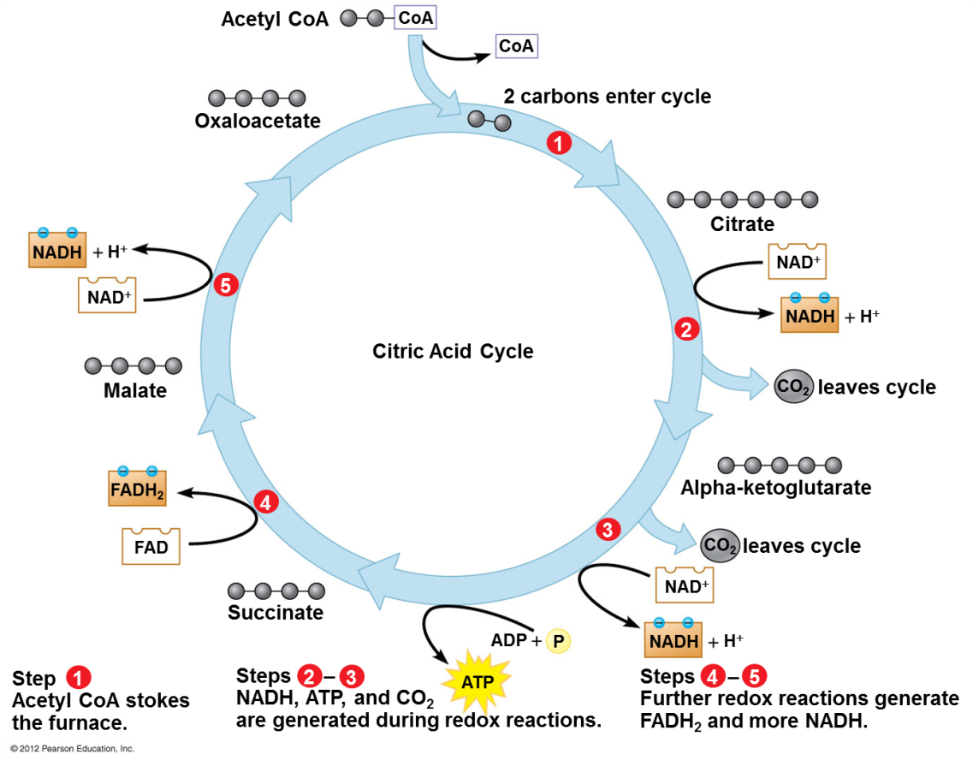
6.10 – Oxidative phosphorylation
- At this point in Cellular Respiration only 4 ATP molecules have been produced
  - 2 in glycolysis
  - 2 in the citric acid cycle
- Oxidative phosphorylation (most ATP is produced here)
  - The energy in NADH and FADH₂ is converted into ATP
  - Involves electron transport and chemiosmosis
  - Requires an adequate supply of oxygen (aerobic)
- Electrons are released from NADH and FADH₂ and travel down electron transport chain to O2
  - ETC: a series of proteins embedded in the inner mitochondrial membrane
- Oxygen “catches” the electrons and picks up H⁺ to form water
- Energy released by redox reactions used to pump H⁺ from mitochondrial matrix into intermembrane space
- In chemiosmosis, H⁺ diffuses back across inner membrane through ATP synthase complexes, driving the synthesis of ATP
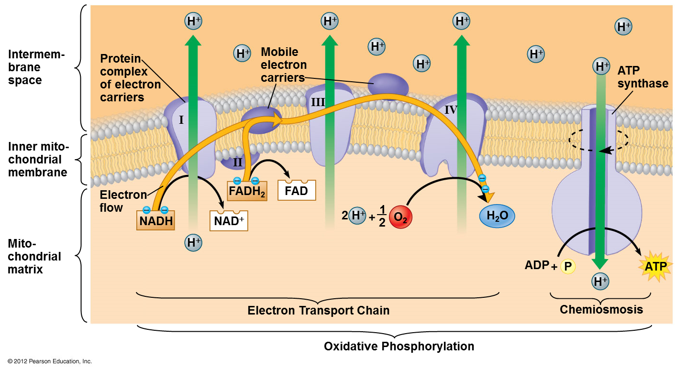
6.12 Review: Each molecule of glucose yields many molecules of ATP
The energy payoff of cellular respiration involves:
- glycolysis
- alteration of pyruvate
- the citric acid cycle
- oxidative phosphorylation
Totals:
- The total yield is about 32 ATP molecules per glucose molecule
  - This is about 34% of the potential energy of a glucose molecule
- Water and CO₂ are also produced
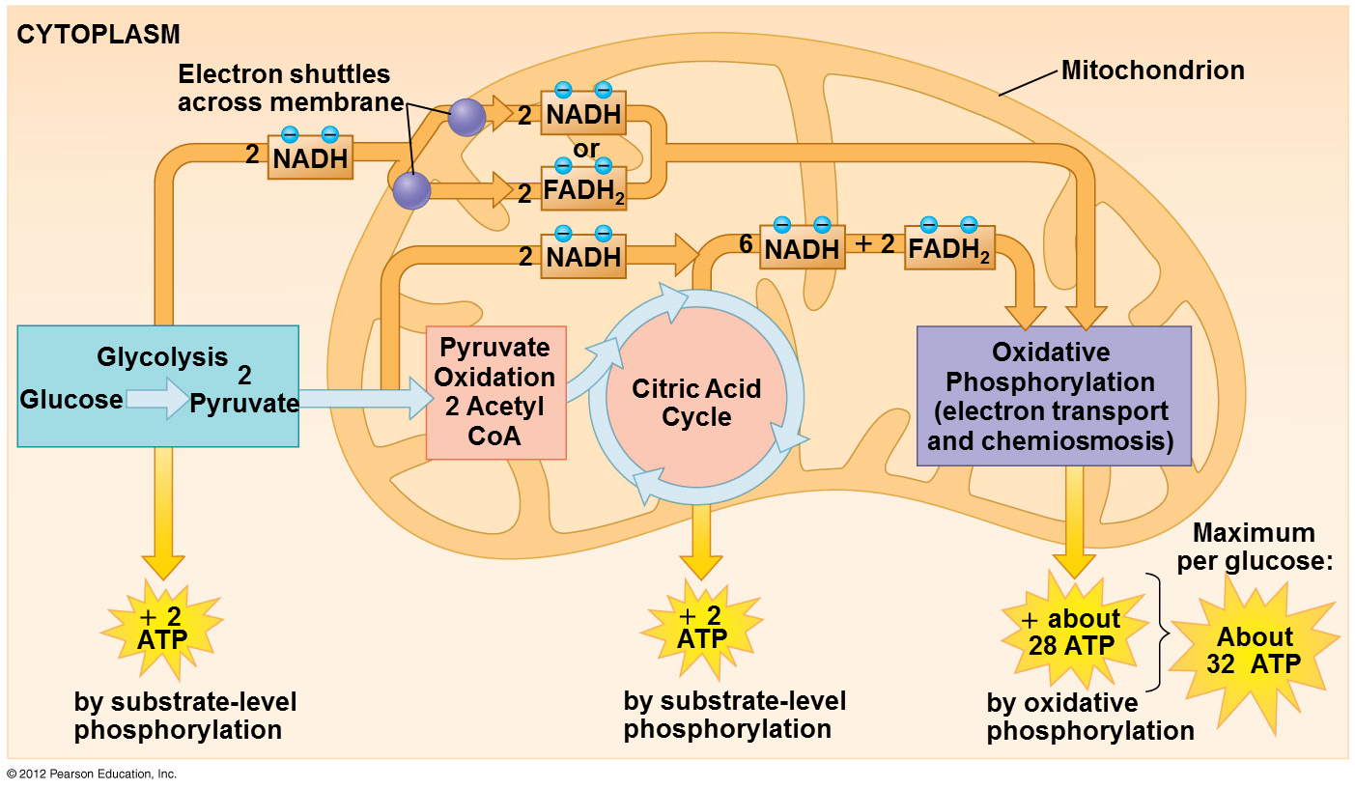

6.13 – Fermentation
- Fermentation: a way of harvesting chemical energy that does not require oxygen (anaerobic)
  - Takes advantage of glycolysis
  - Produces two ATP molecules per glucose
  - Reduces NAD⁺ to NADH
- Fermentation must provide an anaerobic path for recycling NADH back to NAD⁺

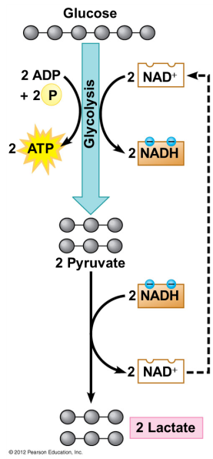
Lactic Acid Fermentation
- Human muscle cells and certain bacteria can oxidize NADH through lactic acid fermentation
  - NADH is oxidized to NAD⁺
  - Pyruvate is reduced to lactate
- Lactic acid fermentation occurs during strenuous activity (exercise)
  - When more ATP than is provided by CR is needed
- Lactate is carried by the blood to the liver
  - Converted back to pyruvate and oxidized in the mitochondria of liver cells
- Bacteria: What foods are produced by lactic acid fermentation?
  - Cheese
  - Yogurt

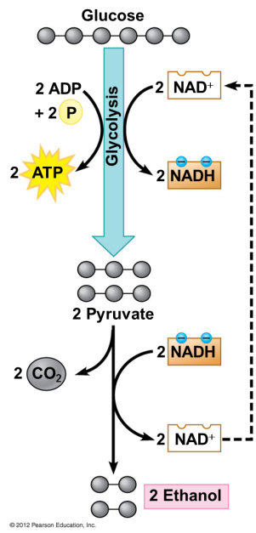
Alcohol Fermentation
- Yeasts (single-celled fungi)
  - Oxidize NADH back to NAD⁺
  - Convert pyruvate to CO₂ and ethanol
- What foods are produced by alcohol fermentation?
  - Bread
  - Alcohol (liquor)
- What if our muscle cells used this process?
  - Every time we exercised, we would be drunk!

Obligate Anaerobes – cells can only function w/o oxygen
Facultative Anaerobes – cells can perform CR or fermentation (muscle cells)

6.14 – EVOLUTION CONNECTION: Glycolysis evolved early in the history of life on Earth
- The ancient history of glycolysis is supported by:
  - Occurrence in all the domains of life
  - Uses pathways that do not involve any membrane-bounded organelles

6.15 - Cells use many kinds of organic molecules as fuel for cellular respiration
- Although glucose is considered to be the primary source of sugar for respiration and fermentation, ATP is generated using:
  - carbohydrates
  - fats
  - proteins
