Chapter 7 Test Study Guide
Photosynthesis: Using Light to Make Food
7.1 – Autotrophs are the producers of the biosphere
- Autotrophs (self-feeders)
  - Photoautotrophs: light energy, photosynthesis
    - Producers
    - Plant products: paper, wood, medicine, etc.
  - Chemoautotrophs: inorganic molecules
- Heterotrophs (other eaters)
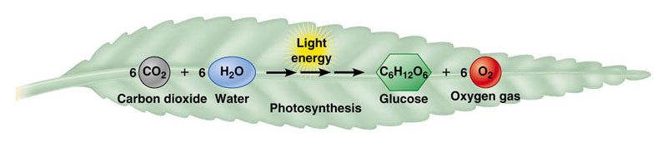
  - Consumers (that’s us!)

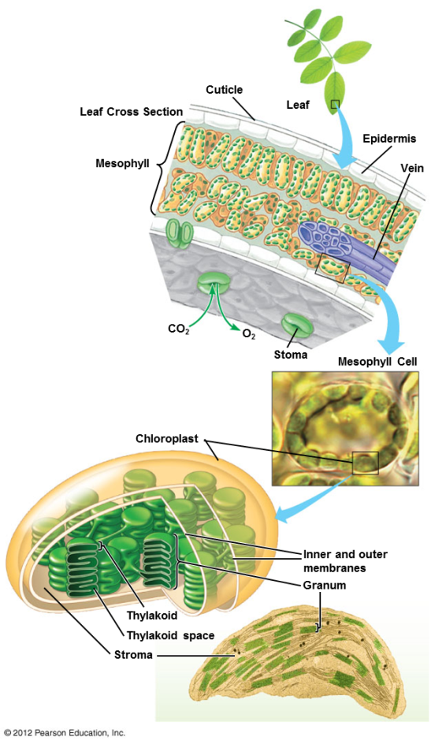
7.2 – Photosynthesis occurs in chloroplasts in plant cells
- Chloroplasts are major sites of photosynthesis in green plants
- Chlorophyll:
  - Light-absorbing pigment in chloroplasts
  - Responsible for the green color of plants
  - Central role in converting solar energy to chemical energy

7.3 – SCIENTIFIC DISCOVERY: Scientists traced the process of photosynthesis using isotopes
- Scientists have known since the 1800s that plants produce O₂; they didn’t know if oxygen came from carbon dioxide or water
  - Research using a heavy isotope of oxygen, ¹⁸O, showed that oxygen produced by photosynthesis comes from H₂O (Neil)
- Experiment 2: 6 CO₂ + 12 H₂O → C₆H₁₂O₆ + 6 H₂O + 6 O₂
- Photosynthesis produces billions of tons of carbohydrate a year. Where does most of the mass for this huge amount of organic matter come from? Answer: carbon dioxide

7.4 – Photosynthesis is a redox process, as is cellular respiration
- Photosynthesis is a redox process (like cellular respiration!)
  - CO₂ becomes reduced to sugar as electrons & hydrogen ions from water are added
  - Water molecules are oxidized when they lose electrons and hydrogen ions
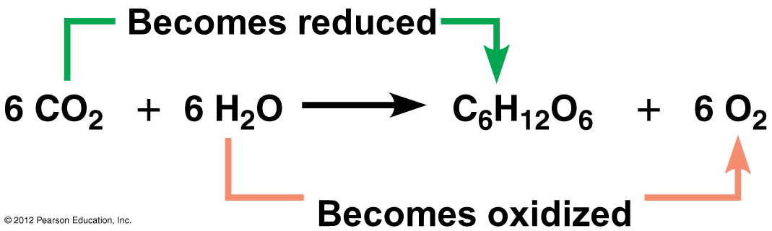
Photosynthesis Summary:
- Requires energy (light)
  - Endergonic
- Light energy is captured by chlorophyll molecules to boost the energy of electrons
- Light reactions: light energy is converted to chemical energy
- Calvin cycle: chemical energy is stored in the chemical bonds of sugars

7.5 – Overview: The two stages of photosynthesis are linked by ATP and NADPH
- Photosynthesis occurs in two metabolic stages
  - The light reactions occur in the thylakoid membranes. In these reactions
    - water is split, providing a source of electrons and giving off oxygen as a by-product
    - ATP is generated
    - NADP⁺ is reduced to NADPH
    - ATP and NADPH are used in the Calvin cycle
  - The second stage is the Calvin cycle, which occurs in the stroma of the chloroplast
    - The Calvin cycle is a cyclic series of reactions that assembles sugar molecules using CO₂ and the energy-rich products of the light reactions. (ATP and NADPH)
    - CO₂ is incorporated into organic compounds in a process called carbon fixation
    - Also called the “light independent reactions” or “dark reactions”
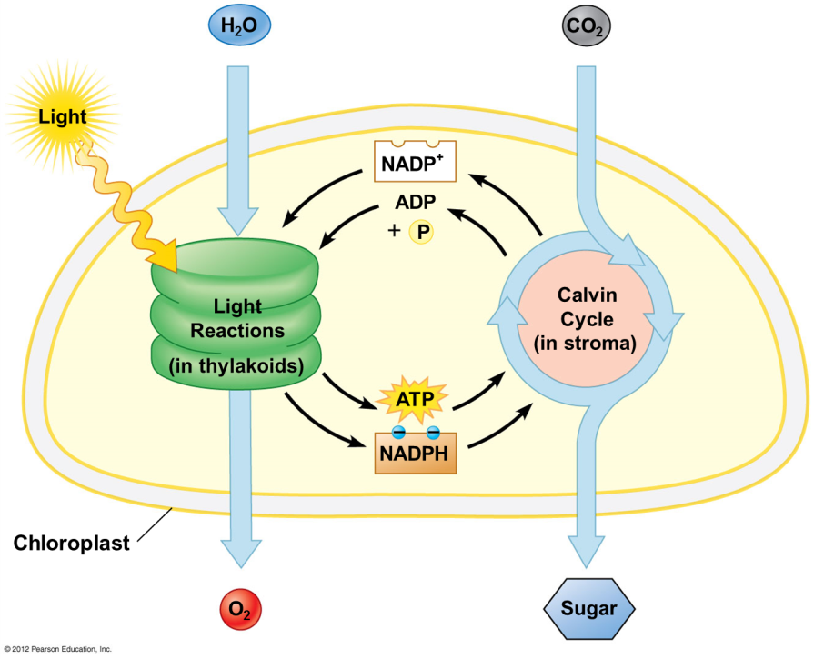

7.6 – Visible radiation absorbed by pigments drives the light reactions
- Sunlight contains energy called electromagnetic energy/radiation
  - Electromagnetic energy travels in waves
    - Wavelength: distance between the crests of two adjacent waves
- Light behaves as discrete packets of energy called photons
  - Photon: a fixed quantity of light energy
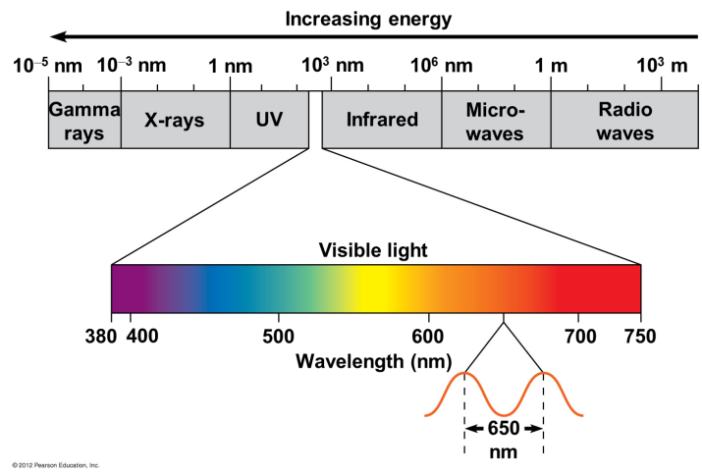
  - Shorter wavelength = greater energy (of the photon)
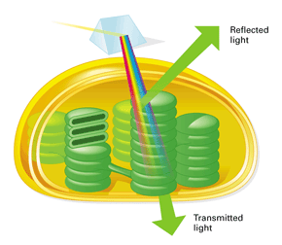
- Plant pigments
  - Light-absorbing molecules
  - Built into the thylakoid membranes
  - Blue green and red orange absorbed
  - Absorb light energy
- Chloroplasts contain several different pigments
  - Chlorophyll a absorbs blue-violet and red light and reflects green
  - Chlorophyll b absorbs blue and orange and reflects yellow-green
  - Carotenoids
    - broaden the spectrum of colors that can drive photosynthesis
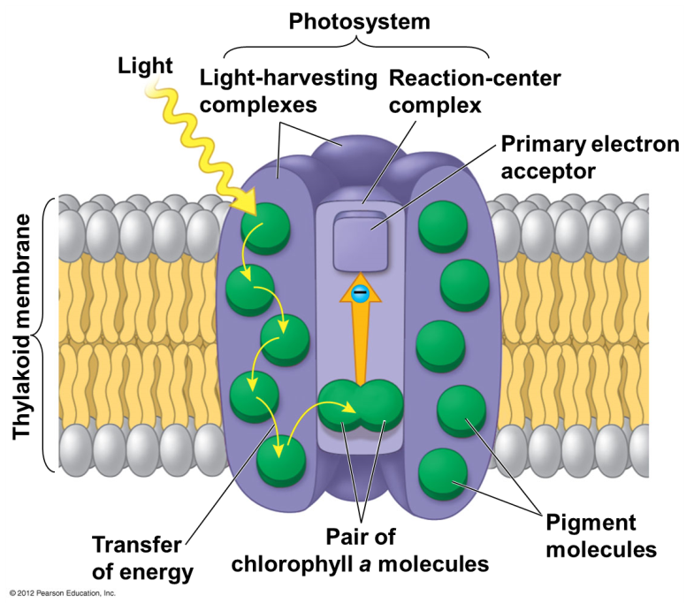
    - provide photoprotection
      - Antioxidant in cells

7.7 – Photosystems capture solar energy
- In the thylakoid membrane, chlorophyll molecules are organized along with other pigments and proteins into photosystems
- Photosystem: light-harvesting complexes surrounding a reaction-center complex
  - Photosystem ll: P680
  - Photosystem l: P700
7.8 – Two photosystems connected by an electron transport chain generate ATP and NADPH
- In the light reactions, light energy is transformed into the chemical energy of ATP and NADPH
- To accomplish this, electrons are
  - removed from water
  - passed from photosystem II to photosystem I
  - accepted by NADP⁺, reducing it to NADPH
- Between the two photosystems, the electrons
  - move down an electron transport chain
  - provide energy for the synthesis of ATP
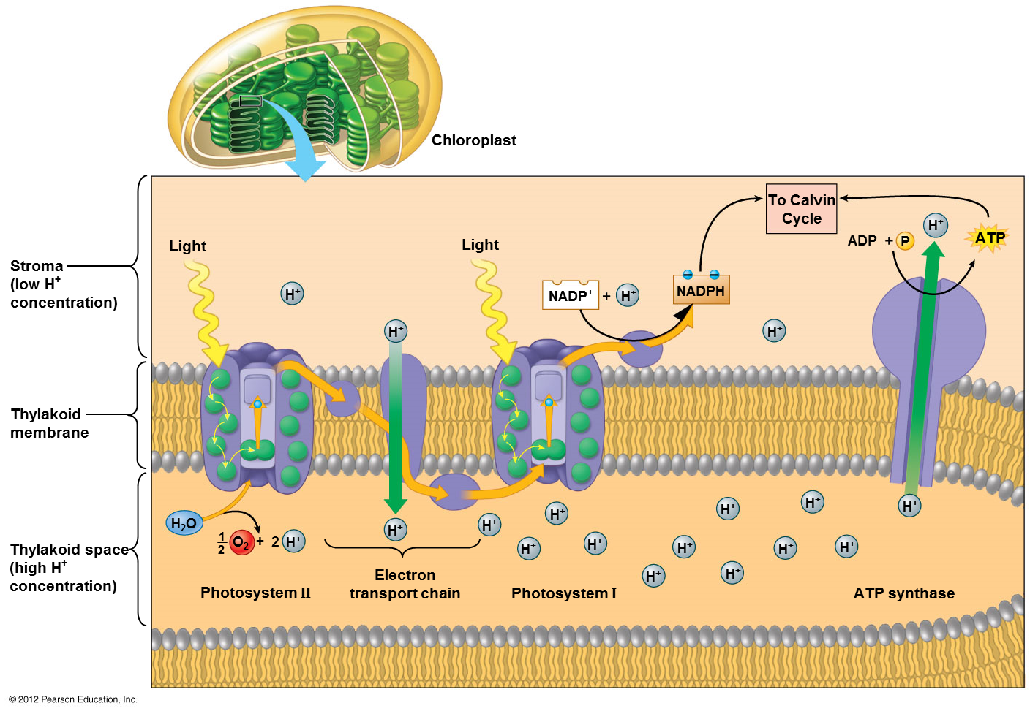
- Products of light reactions:
  - NADPH
  - ATP
  - Oxygen
  - Light energy to chemical energy
  - Why doesn’t photosynthesis stop here?
    - Glucose is needed both to store this energy and for use as plant material

7.9 – Chemiosmosis powers ATP synthesis in the light reactions
- Chemiosmosis:
  - Involved in oxidative phosphorylation in mitochondria
  - Generates ATP in chloroplasts
- ATP is generated because the electron transport chain produces a concentration gradient of hydrogen ions across a membrane
- In photophosphorylation, using the initial energy input from light,
  - Electron transport chain pumps H⁺ into the thylakoid space
  - Resulting concentration gradient drives H⁺ back through ATP synthase, producing ATP

7.10 – ATP and NADPH power sugar synthesis in the Calvin cycle
- Steps of the Calvin cycle:
  - Carbon fixation
  - Reduction
  - Release of G3P
  - Regeneration of the starting molecule – ribulose bisphosphate (RuBP)

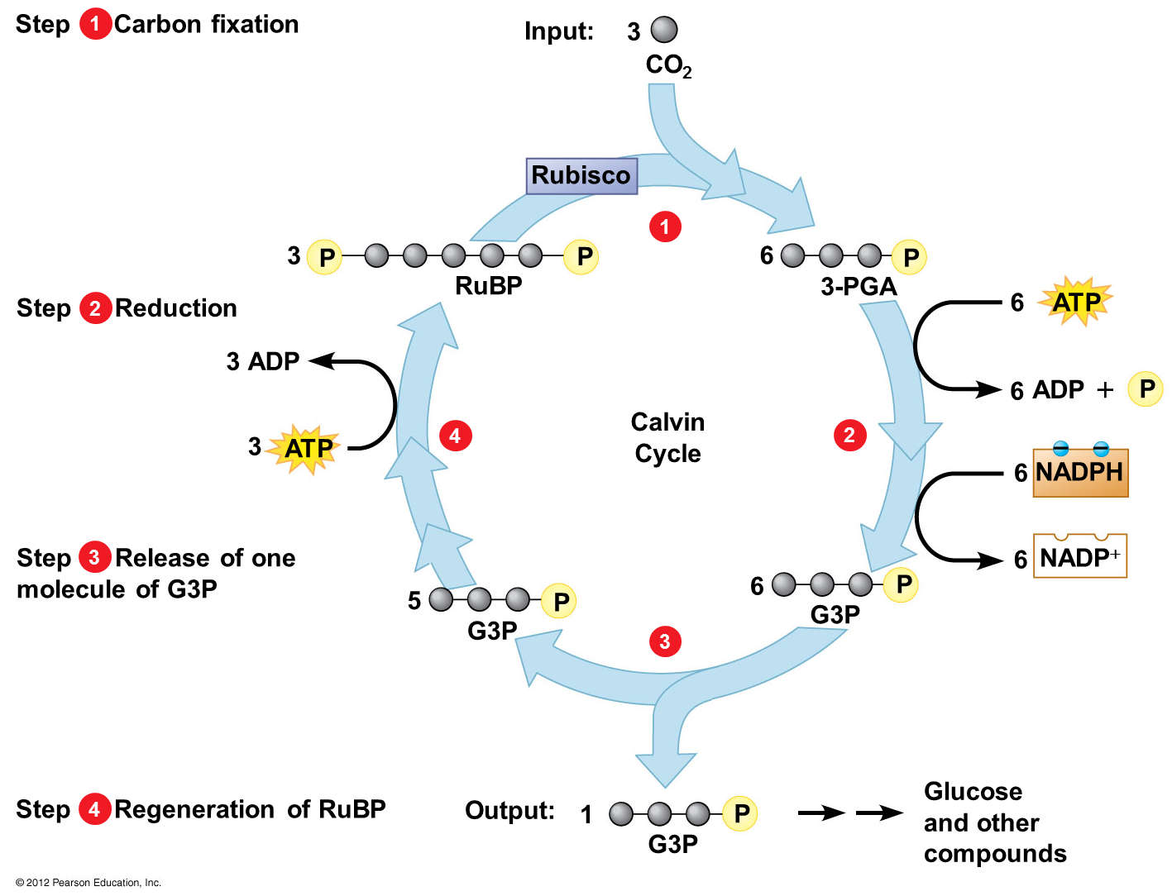
7.11 – EVOLUTION CONNECTION: Other methods of carbon fixation have evolved in hot, dry climates
- C₃ plants
  - First product of carbon fixation is a three carbon compound 3-PGA
  - Close their stomata in hot dry weather in order to prevent dehydration
  - Photorespiration occurs
    - Oxygen builds up, rubisco adds O₂ instead of CO₂ to RuBP resulting in a 2-carbon product which is broken down in the cell using ATP
  - What will happen if this process continues for too long? Answer: plant death
- C₄ plants have evolved a means of
  - carbon fixation that saves water (closed stomata) during photosynthesis
- C₄ plants first fix CO₂ into a four-carbon compound
  - With the help of an enzyme
- The 4-carbon compound “shuttles” the carbon to the Calvin cycle
- CAM plants conserve water by opening their stomata and admitting CO₂ only at night
  - CO₂ is fixed into a four-carbon compound
    - Banks CO₂ at night
    - Releases CO₂ to the Calvin cycle during the day
  - CAM plants include pineapples and cacti

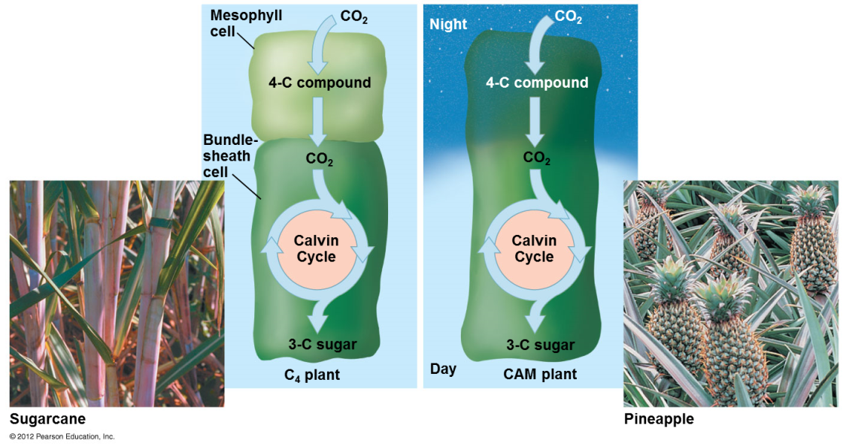

Needed for photosynthesis:
- CO₂ – Calvin cycle – carbon fixation: glucose
- H₂O – light reactions – split: 2H + 2e⁻ + ½O₂
- Light – light reactions – energy
- Chlorophyll – light reactions – absorbs light energy

