Chapter 8 Test Study Guide
The Cellular Basis of Reproduction and Inheritance
Cell Division and Reproduction
8.1 – Cell division plays many important roles in the lives of organisms
- Cell division
  - Reproduction at the cellular level
  - Requires duplication of chromosomes
  - Sorts new sets of chromosomes into resulting pair of daughter cells
- 2 types of cell division
  - Mitosis
    - Asexual reproduction
      - Reproduction of single-celled organisms
      - Reproduction of multicellular organisms (some: ex. starfish)
    - Growth: increase in size
Binary Fission
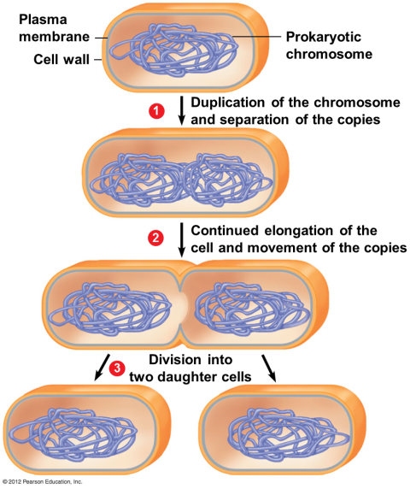
      - Onion root tips
      - Fertilized egg → adult
    - Repair and replacement of cells
  - Meiosis
    - Production of gametes (reproductive cells; haploid)
    - Used in sexual reproduction

8.2 – Prokaryotes reproduce by binary fission
- Prokaryotes (bacteria and Archaea) reproduce by binary fission (“dividing in half”)
- Asexual reproduction

The Eukaryotic Cell Cycle and Mitosis
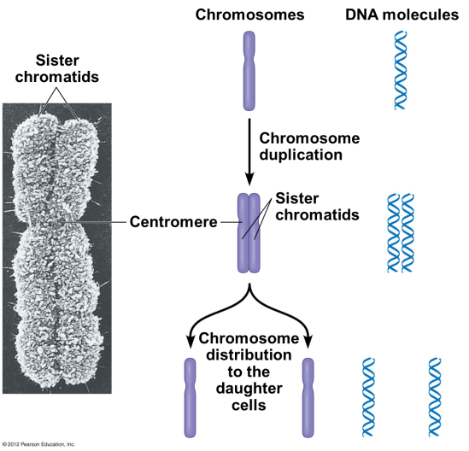
8.3 – The large, complex chromosomes of eukaryotes duplicate with each cell division
- Eukaryotic cells
  - Store most of genes on multiple chromosomes within nucleus
(46 in human cell)
- Eukaryotic chromosomes are composed of chromatin
  - DNA + protein
- To prepare for division, chromatin becomes chromosomes
  - Coiling of chromatin is important – it compacts genes into manageable packages

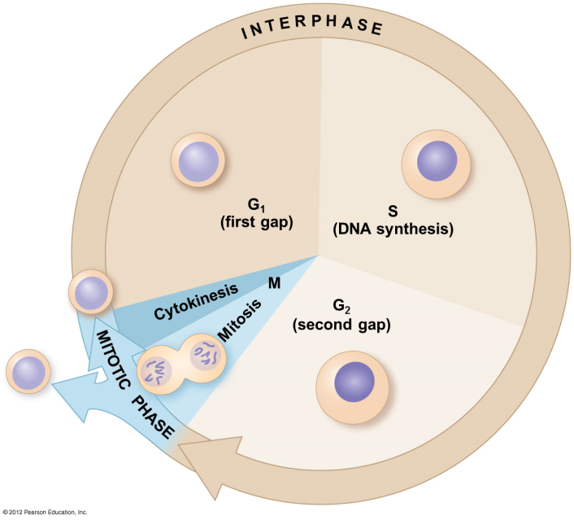
8.4 – The cell cycle multiplies cells
The Cell Cycle
- The cell cycle is an ordered sequence of events
  - Extends from
    - when a cell is first formed from a dividing parent cell
    - until its own division
- Not all cells divide

INTERPHASE
- Most of the cell cycle is spent in interphase (90%)
- Cell performs its various functions
  - White blood cells
  - Intestinal cells
  - Pancreatic cells

- A cell will
  - Make more cytoplasm/create organelles/grow in size
  - Synthesize proteins
  - Synthesize DNA
- 3 parts of interphase
  - G₁: growth and activity following division
  - S: growth and DNA synthesis
  - G₂: growth and activity between DNA replication and division

MITOTIC PHASE (M phase)
- Accounts for 10% of total cell cycle
- Mitosis: nucleus (duplicated chromosomes) divided evenly → 2 daughter nuclei
- Cytokinesis: cytoplasm divided in two
- Result: 2 genetically identical daughter cells

8.5 – Cell division is a continuum of dynamic changes
- Mitosis has 5 main stages (PPMAT)
  - Prophase
  - Prometaphase
  - Metaphase
  - Anaphase
  - Telophase
- Mitotic spindle
  - Required to divide chromosomes
  - Composed of microtubules
  - Produced by centrosomes
    - Organize microtubule arrangement
    - Contain a pair of centrioles in animal cells

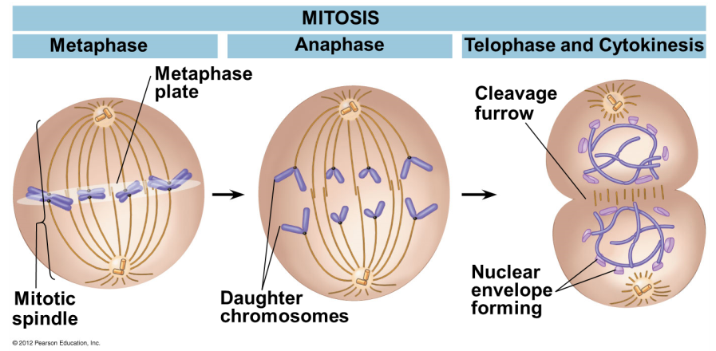
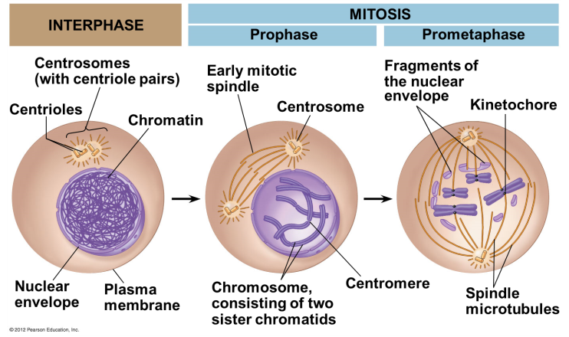
Interphase
- Cytoplasmic contents double
- 2 centrosomes form
- Chromosomes duplicate in nucleus during S phase
- Nucleoli (sites of ribosome assembly) are visible
Prophase
- In cytoplasm, microtubules emerge from centrosomes, forming spindle
- In nucleus
  - Chromosomes coil & become compact
  - Nucleoli disappear
Prometaphase
- Spindle microtubules reach chromosomes
  - Attach at kinetochores on centromeres of sister chromatids
  - Move chromosomes to center of cell through associated protein “motors”
- Nuclear envelope disappears
Metaphase
- Mitotic spindle is fully formed
- Chromosomes align at cell equator
- Kinetochores of sister chromatids are facing opposite poles of spindle
Anaphase
- Sister chromatids separate
- Daughter chromosomes are moved to opposite poles
  - Motor proteins move chromosomes along spindle microtubules
  - Kinetochore microtubules shorten
- Cell elongates
Telophase and Cytokinesis
- Cell continues to elongate
- Nuclear envelope forms around chromosomes at each pole
- Chromatin uncoils & nucleoli reappear
- Spindle disappears
- During cytokinesis, cytoplasm is divided into separate cells
8.6 – Cytokinesis differs for plant and animal cells
Cytokinesis differs in plant and animal cells because plant cells, unlike animal cells, have a cell wall.

Cytokinesis in animal cells
- Cleavage furrow forms via contracting ring of microfilaments, interacting with myosin
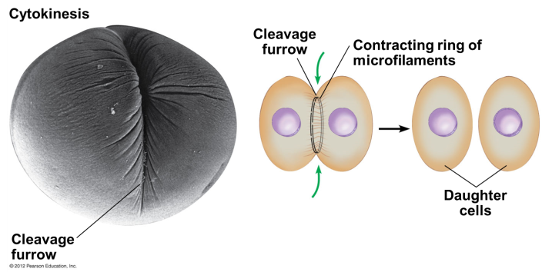

Cytokinesis in plant cells
- Cell plate forms in middle, from vesicles containing cell wall material
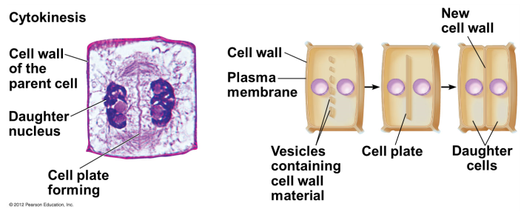
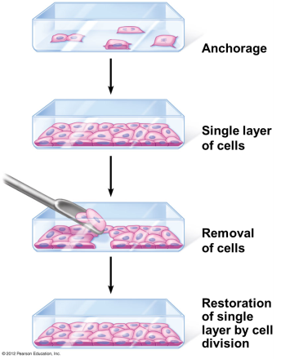
8.7 – Anchorage, cell density, and chemical growth factors affect cell division
- Cells within organism’s body divide and develop at different rates
- Cell division is controlled by
  - Presence of essential nutrients
  - Growth factors (proteins that stimulate division)
    - VEGF: vascular endothelial growth factor
  - Density-dependent inhibition: crowded cells stop dividing
    - Signal is sent out to fill in empty spaces in the body
  - Anchorage dependence: need for cells to be in contact with a solid surface to divide
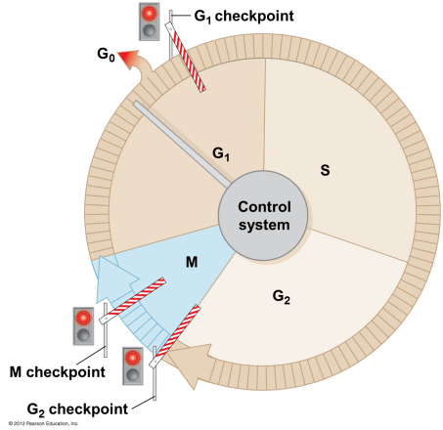
8.8 – Growth factors signal the cell cycle control system
- Cell cycle control system: cycling set of molecules in the cell
  - Triggers & coordinates key events in cell cycle
- Checkpoints in cell cycle can
  - Stop an event
  - Signal an event to proceed
- 3 major checkpoints in cell cycle
  - G₁ checkpoint
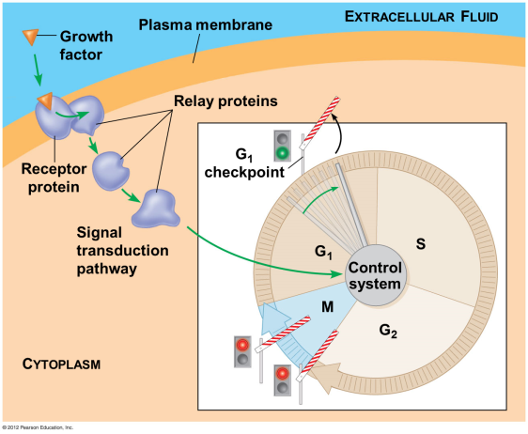
    - Allows entry into S phase
    - Causes cell to leave cycle, entering non-dividing G₀ phase (ex. cardiac & brain cells)
  - G₂ checkpoint
    - Is DNA replicated? Is it damaged?
  - M checkpoint
    - Are chromatids attached to spindles?
8.9 – CONNECTION: Growing out of control, cancer cells produce malignant tumors
- Transformation
- Cancer cells escape controls on cell cycle
- Cancer cells
  - Caused by problem with 1 or more checkpoints
    - Result of mutation in DNA
  - Divide rapidly, often in absence of growth factors
  - Spread to other tissues via circulatory system
  - Grow w/o being inhibited by other cells
  - Form tumors
    - Benign
      - encapsulated (contained) – stay in one place
    - Malignant, metastasis (spread of cancer cells to other places)
      - usually leak into bloodstream & spread throughout body
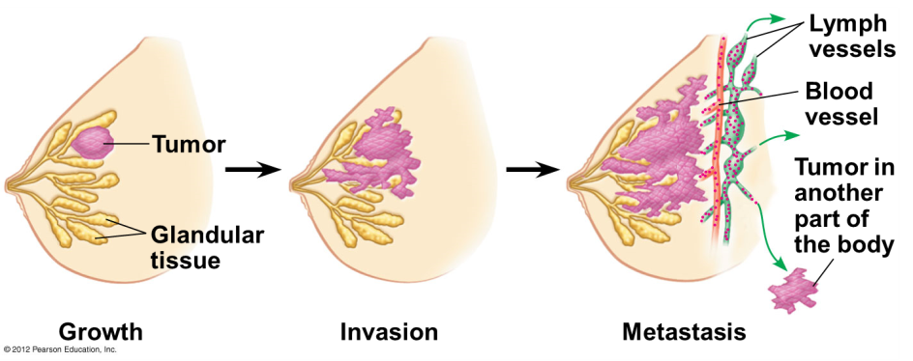
- Cancers are named according to organ or tissue in which they originate
  - Carcinomas arise in external or internal body coverings
    - Ex. Skin lining of intestine
  - Sarcomas arise in supportive and connective tissue
    - Ex. Bone and muscle
  - Leukemias & lymphomas arise from blood-forming tissues
- Cancer cells are immortal
- Cancer treatments
  - Surgery
  - Radiation
  - Chemotherapy is used for metastatic tumors
    - Taxol (yew) freezes mitotic spindle
    - Vinblastin (periwinkle) prevents formation of mitotic spindle

8.10 – Review: Mitosis provides for growth, cell replacement, and asexual reproduction
- Mitosis
  - Growth
  - Cell replacement
  - Asexual reproduction
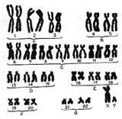
Meiosis and Crossing Over
Karyotype
8.11 – Chromosomes are matched in homologous pairs
- In humans, typical body cell (somatic cell) has 46 chromosomes
  - 23 pairs of homologous chromosomes
  - 1 of each pair from each parent
    - Every chromosome has a twin
    - 2 chromosomes of this pair are called homologous chromosomes
- Homologous chromosomes (or homologs)
  - 2 chromosomes in each matching pair
  - Both carry genes controlling same inherited characteristics
  - Matched in length, centromere position, gene locations
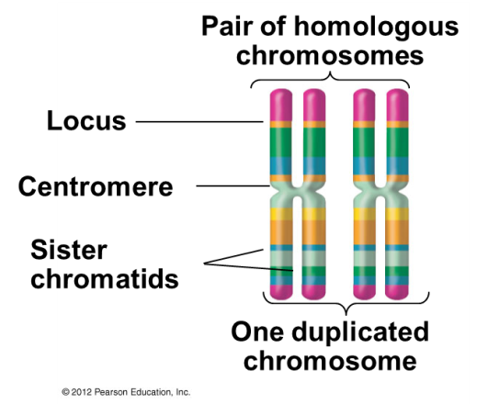
  - Locus (pl. loci): particular site where a gene is found on a chromosome (true position of the gene)
    - Homologous chromosomes have genes for same characteristic at corresponding loci
    - 2 chromosomes of a homologous pair may have different versions of the same gene
  - Alleles: form of the gene (ex. blue vs. brown eyes)
- Sex chromosomes
  - In females, all chromosomes are homologous
- Remaining 22 chromosomes are called autosomes
  - Found in both males and females
- Karyotype: picture of the 23 pairs of homologous chromosomes
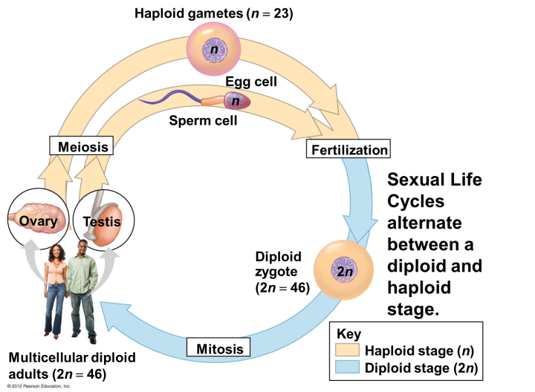
8.12 – Gametes have a single set of chromosomes
- Diploid number (2n)
  - Somatic cells
  - Humans: 46
  - 1 set of chromosomes from each parent
(2 sets total)
- Haploid number (n)
  - Gametes
  - Humans: 23
  - 1 set of chromosomes
- Gametes must by haploid so you get 46 chromosomes in the new cell (fertilized egg)
- Meiosis: process that converts diploid to haploid nuclei
  - Occurs in sex organs, producing gametes (sperm and eggs)
- Fertilization: combination of sperm and egg cells (gametes)
- Zygote: fertilized egg (2 gametes → 1 zygote

MEIOSIS I
- Separation of homologous pairs
- Genetically different haploid cells

MEIOSIS II
- Separation of sister chromatids
- 4 haploid gametes

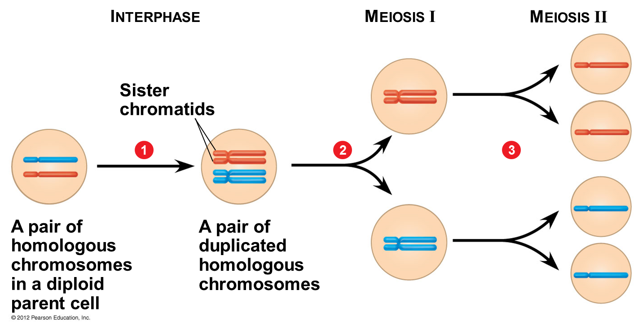

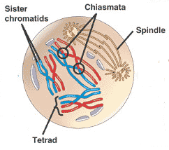
8.13 – Meiosis reduces the chromosome number from diploid to haploid
- Interphase: DNA replication
- Meiosis I – Prophase I – events occurring in the nucleus
  - Chromosomes coil and become compact
  - Homologous chromosomes some together as pairs by synapsis
  - Tetrad: pair of homologous chromosomes
  - Crossing-over: a piece of 1 homologous chromosome swaps places w/ another

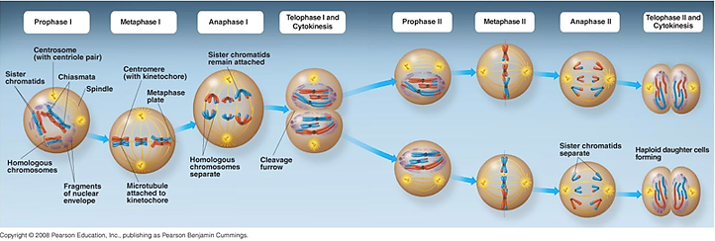

8.14 – Mitosis and meiosis have important similarities and differences
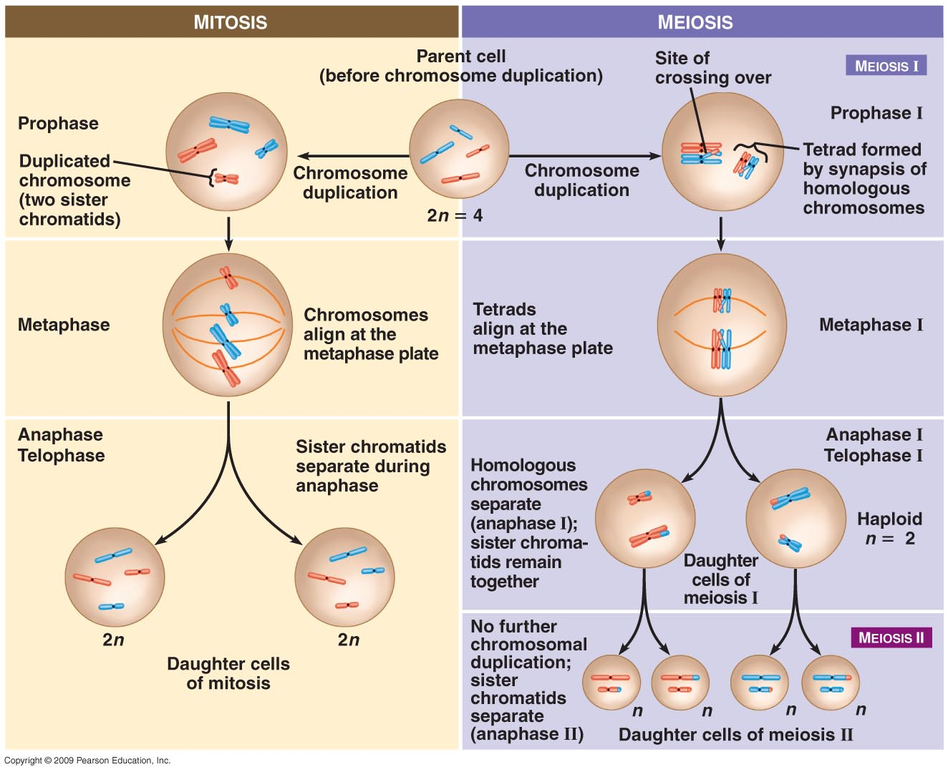

8.15 – Independent orientation of chromosomes in meiosis and random fertilization lead to varied offspring
- Independent orientation at metaphase I
  - Example:
    - Number of combinations for chromosomes packaged into gametes is 2^{n} (n = haploid)
  - How many combinations for humans?
    - 2²³ = 8,388,608
- Random Fertilization
  - Possible combinations after fertilization?
    - 8 million x 8 million = 64 trillion combinations of chromosomes

8.16 – Homologous chromosomes may carry different versions of genes

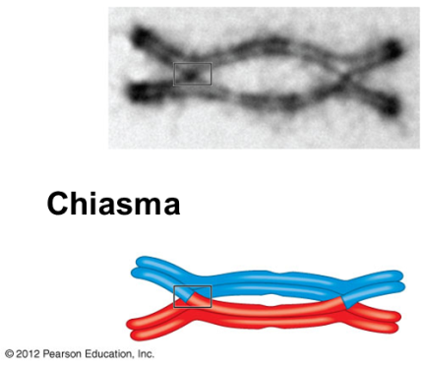
8.17 – Crossing over further increases genetic variability
- Genetic recombination: production of new combinations of genes due to crossing over
- Even w/o crossing over, genetic information in new cells is still different because there is DNA from both parents and in random formations because of separation of chromosomes in metaphase

Alterations of Chromosome Number and Structure
8.18 – A karyotype is a photographic inventory of an individual’s chromosomes
8.19 – CONNECTION: An extra copy of chromosome 21 causes Down syndrome
- Trisomy 21
  - Involves inheritance of 3 copies of chromosome 21
  - Most common human chromosome abnormality

8.20 – Accidents during meiosis can alter chromosome number
- Nondisjunction: members of chromosome pair fail to separate
  - Chance increases w/ maternal age (older than 35)
  - Can happen in either meiosis I or II
    - Either homologous chromosomes or sister chromatids fail to separate
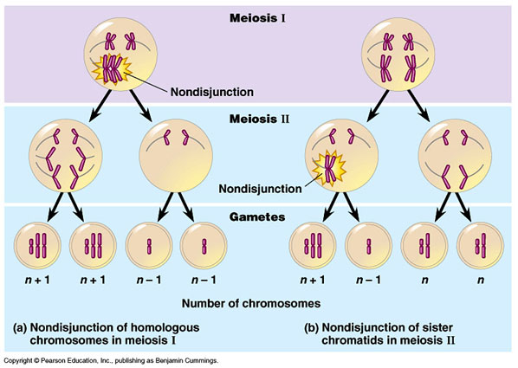

8.21 – CONNECTION: Abnormal numbers of sex chromosomes do not usually affect survival
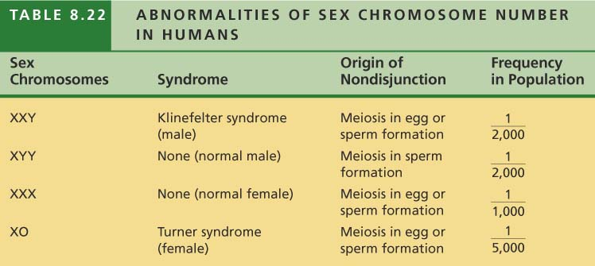

8.22 – EVOLUTION CONNECTION: New species can arise from errors in cell division
8.23 – CONNECTION: Alterations of chromosome structure can cause birth defects and cancer
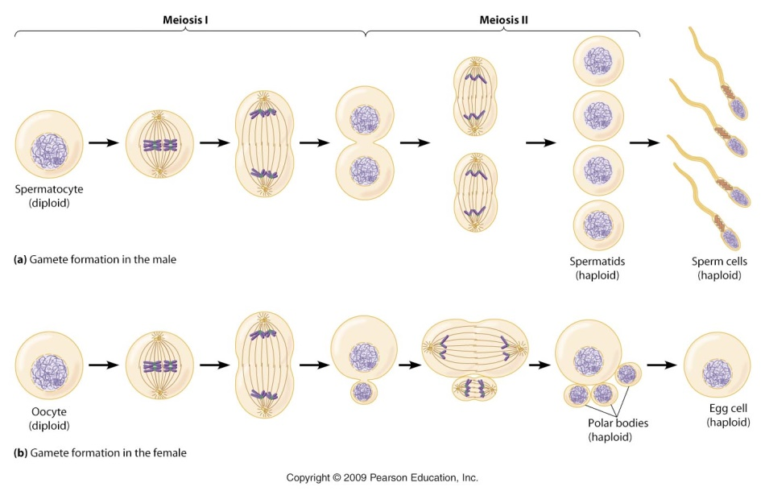
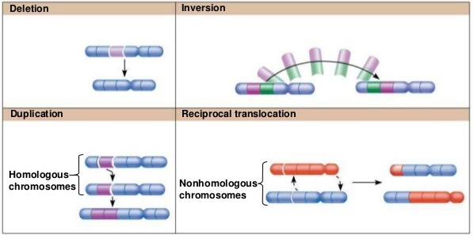
A segment of a chromosome is removed
A segment of a chromosome is copied and inserted into the homologous chromosome
A segment of a chromosome is removed and then reinserted “backward” to its original orientation
Segments of two nonhomologous chromosomes swap locations with each other
Spermatogenesis
Oogenesis

