Chapter 9 Test Study Guide
Patterns of Inheritance
Mendel’s Laws
9.1 – The science of genetics has ancient roots
- Blending hypothesis: genetic material from each plant “mixed”
  - Was later rejected because when red & white flowers were mixed into pink flowers, the pink flowers could produce red, white, & pink flowers – the genes did not “mix” like paint (they could be separated)
9.2 – Experimental genetics began in an abbey garden
- Heredity: transmission of traits from one generation to the next
- Genetics: study of heredity
- Gregor Mendel
  - “Father of genetics”
  - Garden peas
  - Relied upon mathematics, physics, chemistry
- Mendel 1866:
  - Parents pass on to their offspring discrete “heritable factors”
  - Heritable factors (genes) retain their individuality generation after generation
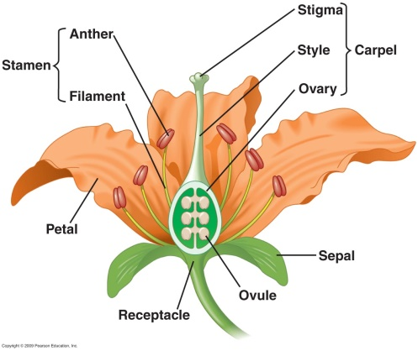
    - Playing cards in a deck
- Characteristic: a heritable feature
- Trait: each variant for a characteristic
- Reproductive Structures
  - Pea plants are self-pollinating
  - Stamen produces pollen (sperm)
  - Pistil (carpel) produces eggs
  - Pollen + egg → embryo
  - Next generation would be identical
- True-breeding varieties result when self-fertilization produces offspring all identical to the parent
- Cross fertilization of two different varieties results in hybrids
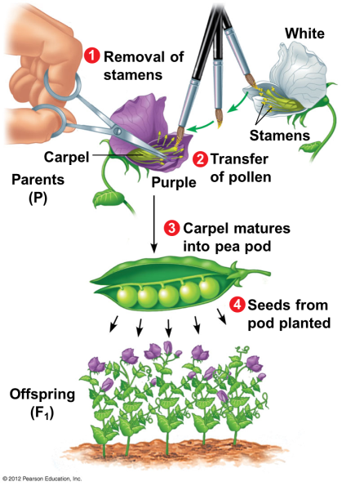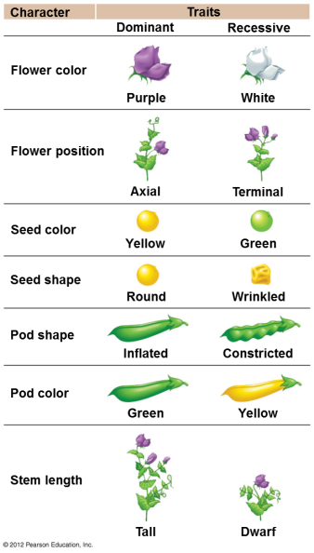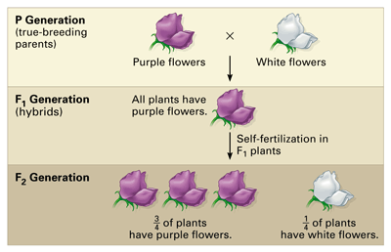
9.3 – Mendel’s law of segregation describes the inheritance of a single character
- Monohybrid cross: cross between 2 individuals differing in a single characteristic
  - Cross between purple & white
- Mendel developed 4 hypotheses:
  - Alleles are alternative versions of genes that account for variations in inherited characteristics.
    - Genotype (letters)
    - Phenotype (physical characteristics)
  - For each characteristic, an organism inherits 2 alleles, 1 from each parent. Alleles can be the same or different.
    - Homozygous genotype (PP, pp)
    - Heterozygous genotype (Pp)
  - If the alleles of an inherited pair differ, then one determines the organism’s appearance and is called the dominant allele (capital letter). The other has no noticeable effect on the organism’s appearance and is called the recessive allele (lower case letter).
  - A sperm or egg carries only one allele for each inherited character because allele pairs separate (segregate) from each other during the production of gametes. This statement is called the law of segregation.
- Explains 3:1 ratio in F₂ generation
  - Punnett square
9.4 – Homologous chromosomes bear the alleles for each character
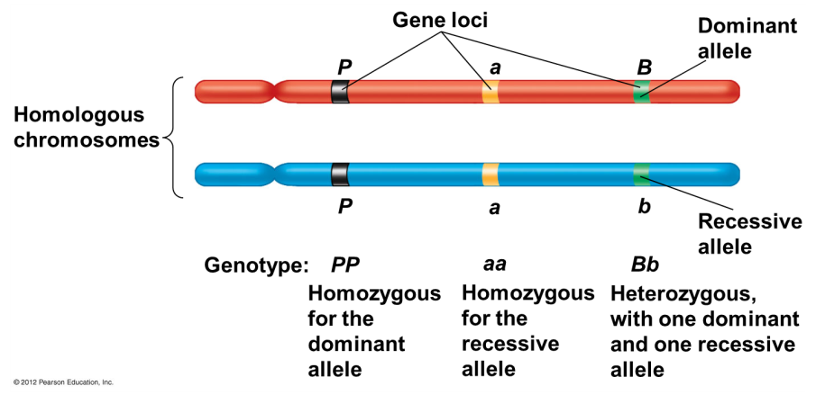
9.5 – The law of independent assortment is revealed by tracking two characters at once
- Dihybrid cross: plants are crossed that differ in 2 characteristics
- Characteristics assort independently
  - Inheritance of one character has no effect on the inheritance of another
  - Independent assortment occurs only when traits are on different chromosomes
- Mendel performed the following dihybrid cross with the following results:
  - P generation: round yellow seeds x wrinkled green seeds
  - F1 generation: all plants with round yellow seeds
  - F2 generation: (phenotypic ratio: 9:3:3:1)
    - 9/16 had round yellow seeds
    - 3/16 had wrinkled yellow seeds
    - 3/16 had round green seeds
    - 1/16 had wrinkled green seeds
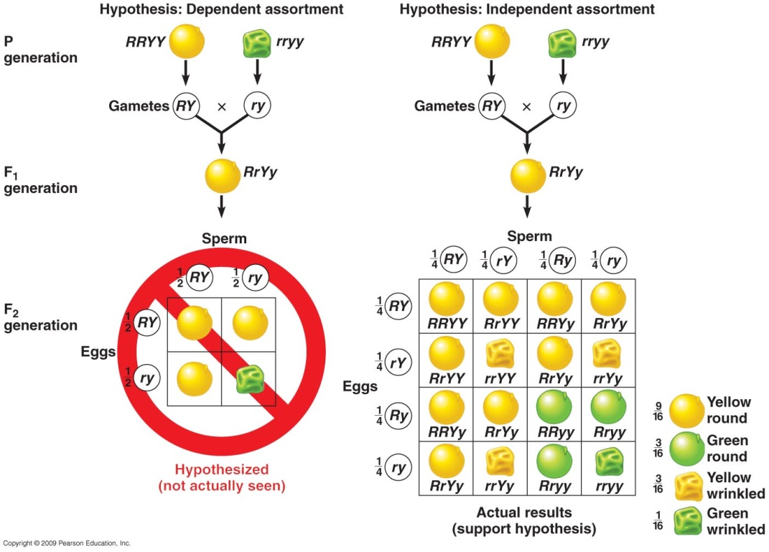
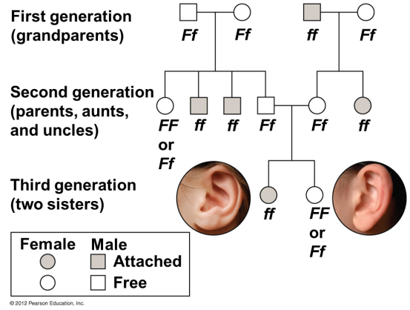
9.8 – CONNECTION: Genetic traits in humans can be tracked through family pedigrees
- Mendel’s laws apply to inheritance of many human traits
- Wild-type traits: prevailing in nature, not necessarily specified by dominant alleles
- Pedigree: shows inheritance of a trait in a family through multiple generations

9.9 – CONNECTION: Many inherited disorders in humans are controlled by a single gene
- Inherited human disorders can show either
  - Autosomal recessive disorder
    - Heterozygous parents are carriers of the disease-causing allele (ex. Cystic fibrosis)
    - Probability of inheritance increases w/ inbreeding
  - Autosomal dominant disorder
    - 1 dominant allele is needed to show disease (ex. Achondroplasia & Huntington’s)

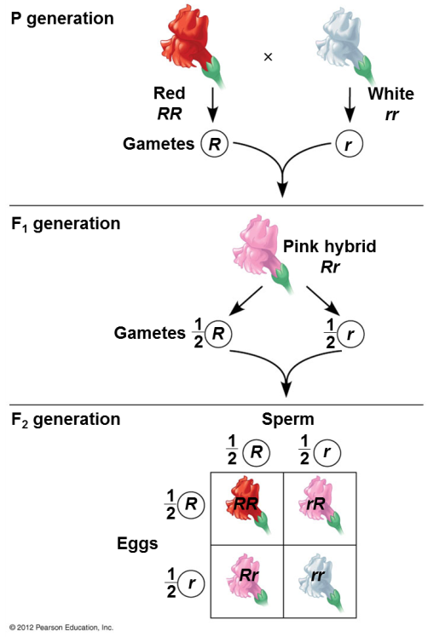
Variations on Mendel’s Laws
9.11 – Incomplete dominance results in intermediate phenotypes
- Mendel’s pea crosses always looked like one of the parental varieties, called complete dominance
- Incomplete dominance: the appearance of F₁ hybrids falls between the phenotypes of the two parental varieties
  - Neither allele is dominant over the other
  - Expression of both alleles occurs
  - Example: cross a red flower with a white flower

- Codominant alleles
  - Both alleles are expressed → see both characteristics
  - Ex. Erminette chickens (speckled, not just black or just white)

9.12 – Many genes have more than two alleles in the population
- Human ABO blood group phenotypes involve 3 alleles for 1 gene
- 4 human blood groups (A, B, AB, O) result from combinations of these alleles
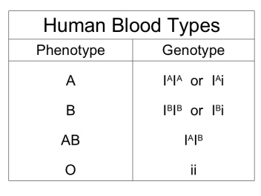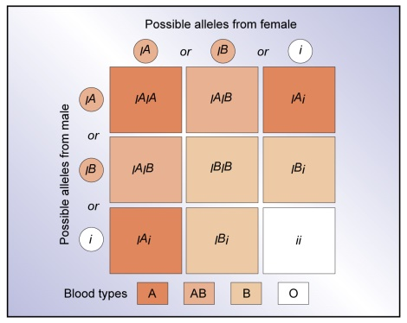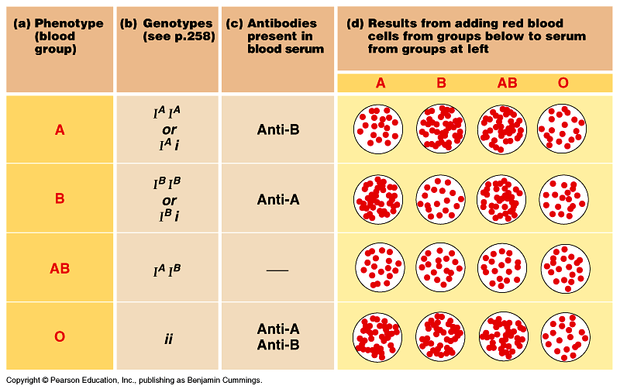

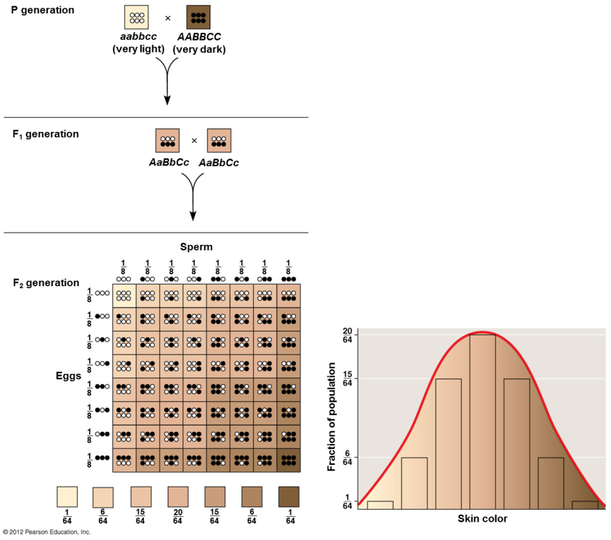
9.13 – A single gene may affect many phenotypic characters
- Pleiotropy occurs when one gene influences many characteristics
  - Sickle-cell disease is a human example
  - Must be homozygous

9.14 – A single character may be influenced by many genes
- Polygenic inheritance: single phenotypic character results from additive effects of two or more genes
  - Human skin color
9.15 – The environment affects many characters
- Many characters result from a combination of heredity and the environment. For example,
  - Skin color/sunlight
  - Susceptibility to diseases
  - Intelligence/experience
- Only genetic influences are inherited
- ABO blood type vs blood count

The Chromosomal Basis of Inheritance
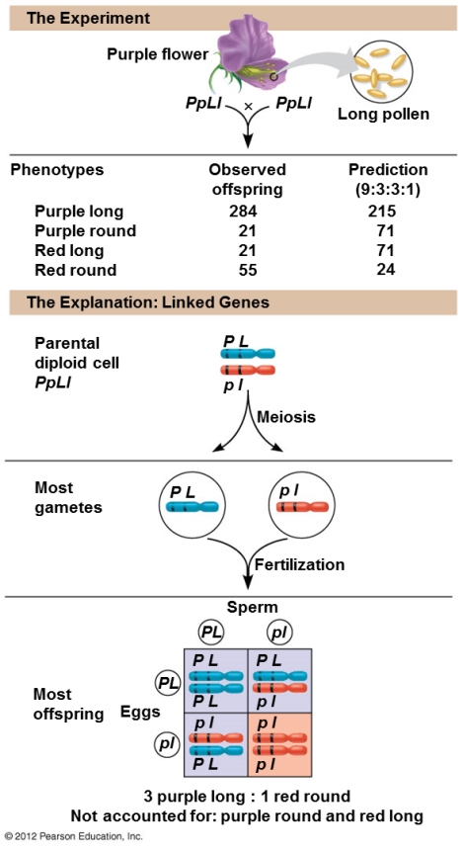
9.16 – Chromosome behavior accounts for Mendel’s laws
- The chromosome theory of inheritance states that
  - Genes occupy specific loci (positions) on chromosomes
  - Chromosomes undergo segregation and independent assortment during meiosis
- Mendel’s laws correlate with chromosome separation in meiosis.
  - The law of segregation depends on separation of homologous chromosomes in anaphase I
  - The law of independent assortment depends on alternative orientations of chromosomes in metaphase I

9.17 – SCIENTIFIC DISCOVERY: Genes on the same chromosome tend to be inherited together
- Bateson and Punnett studied plants that did not show a 9:3:3:1 ratio in the F₂ generation
  - Found an example of linked genes:
    - Located close together on the same chromosome
    - Tend to be inherited together
- Linked alleles can be separated by crossing over, forming recombinant gametes

