The Liturgical Calendar: The Church Year
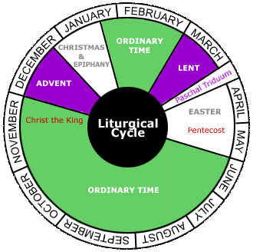
We have our own calendar that we use throughout the year, commonly known as the Gregorian calendar or the "Western calendar", which is today's internationally accepted calendar - it is used throughout the world. However, the (Roman) Catholic Church has its own calendar: the liturgical calendar. The recognized seasons of this calendar celebrate different events in Christ's life and are Advent, Christmas, Ordinary Time (Time after Epiphany), Lent, Easter, and Ordinary Time again (Time after Pentecost).

Advent
- "coming"
- color: purple/blue
- beginning of the liturgical year
- starts four Sundays before Christmas
- ends on Christmas Eve
- prep time for Christmas

Christmas
- celebrates the birth of Christ
- color: white/gold
- starts on Christmas Eve: December 24th (when Advent ends)
- ends on the third Sunday after Christmas (with the Baptism of Jesus)

Events:
- Feast of the Holy Family (Jesus, Mary, & Joseph)
- Epiphany (3 Kings)
- Baptism of Jesus - ends the Christmas season

Ordinary Time I
- 60% of the calendar
- color: green
- starts on the day after the Baptism of Jesus
- ends on the day before Ash Wednesday
- no major preparations or feasts
- when we focus on Jesus' life and teaching

Lent
- preparation time for Easter
- color: purple
- starts on Ash Wednesday (determined by counting 40 days [w/o Sundays] back from Easter)
- ends on Holy Thursday night
- lasts 40 days (not counting Sundays, which are technically mini Easters)
- Triduum happens during Lent

Easter
- color: white/gold
- starts on the Sunday after the first full moon in spring, which starts on March 21st
- ends on Pentecost
- lasts 50 days

Ordinary Time II
- color: green
- starts on the day after Pentecost
- ends on the day before Advent
- a big chunk of the year
- refer to Ordinary Time I for more info

